(Approx. 731 words)

Two great iPhone/iPad Native application features
By Bill Crowe, 1st Vice President, The Sarasota Technology Users Group, Florida
November 2016 issue, STUG Monitor
www.thestug.org
vp1 (at) thestug.org

Everywhere we go on the internet there seems to be a request to set up an account and establish a password for that account. While this is for my own protection, I, like many folks, can never remember the passwords. So, I write them down. But when I need them I never have them with me. Or they are outdated because I did not write down the update, or even worse I cannot read what I wrote. I decided to put them on My iPhone and iPad using the Notes application. At this point, many of you are thinking “ARE YOU NUTS”, your notes are not secure. Well with one of the many new features of the notes application comes the ability to Password protect a note. So now I can put all my passwords in one note, password protect it and I am all set. The only problem now is not to forget that password. What I do, in case that happens, is print out that note just in case. So now all we need to now is how to password protect a note and remember that one password. You will need to have iOS 9.3 or later then follow these steps to pass
word protect a note.
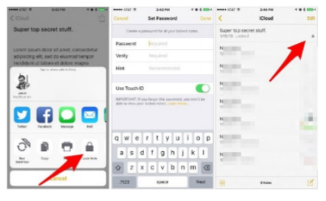
1. First, start by selecting a note you’d like to lock down with a password or Touch ID.

2. Tap on the share button in the upper-right hand corner.

3. Select Lock Note from the list of options. If this is the first time you’ve selected this option, you’ll have to enter a password and a password hint. Notice the warning just below the password section: You cannot access any secured notes on non-iOS 9.3 or Mac OS X 10.11.4 devices. If you’d like to use Touch ID in addition to a password, leave the switch in the On position.

Alternatively, you can set up or change your Notes password by launching the Settings app on your iOS device, then going to Notes > Password.

With a password set, the next time you select Lock Note from the share menu, the note will be placed behind your password. You can identify which notes are protected when viewing the list of notes in your account thanks to a lock icon placed to the right of the title.

The second tip is how to change your wake-up music to more than a “BUZZ”. There may be a number of great alarm clock apps in the App Store that offer various features, but for most of us, the stock Clock app on iPhone is just what we need: it looks good and works great. If you want to give the native alarm option a try, you may find that it is the only app you need to wake you up in the morning.

Not only that, but Apple also added a plethora of chimes and tones to keep your ears interested, or at least to get your brain to wake up in the morning. But if you are tired of being waken up to the sound of “Night Owl” and “By the Seaside” you will be happy to know that you can add your own music as the alarm sound.

To edit the current alarm, follow these steps:
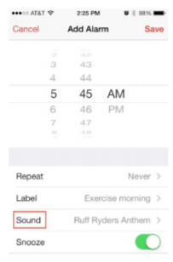
Step 1: Open the Clock app.

Step 2: Select the “Alarm” tab from the icons at the bottom.

Step 3: Tap the “Edit” button in the top left corner of the screen.

Step 4: Select the alarm you wish to use a song for.

Step 5: Tap “Sound.”

Step 6: Under “Songs” tap, “Pick a Song.”

Step 7: Select a song from your device’s music library.

To set up a new alarm:
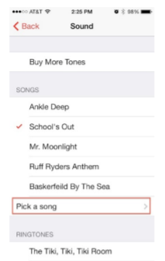
Step 1: Open the Clock app.

Step 2: Select “Alarm” from the icons at the bottom.

Step 3: Tap the plus + button in the top right corner of the screen.

Step 4: Set the time, recurrence, and label if you want to.

Step 5: Tap “Sound.”

Step 6: Under “Songs” tap, “Pick a Song.”

Step 7: Select a song from your device’s music library.

If you use Siri to set your alarm, the alarm sound will be the last one you set up.
Happy wake up……

